
V3 23 Aug 2019
Migration roadmaps

High level migration approach and key milestones
ENGAGE
Local authority and HMLR

Make it happen
Make it stick
Make it ready
Migration activity
Prepare
Migrate

Go live

- Identify affected local authority stakeholders
- Assess existing processes
- Agree post go-live processes
- Understand local authority impact
- Sign Collaboration Agreement
- Agree Delivery Plan
- Assign HMLR resources to support local authority
- Identify risks
- Scan*
- Extract*
- Digitise*
- Analyse*
- Transform*
- Quality assurance
- Train ready for live service
- Sign-off
- Serve notice
- Handover from local authority to HMLR

- Launch live service
- Support for local authorities and customers
- Evaluate – lessons learned
- Ongoing quality assurance
- Collect management information to improve service

Notice period

Customer
- Identify affected customers

- Publicise transition to HMLR service
- Provide customer training
- Collect customer feedback

- Raise customer awareness of the change – targetted to support local authority ahead of go-live
- Amend local authority website and results to communicate the change

*See definitions

Migration journey by record type
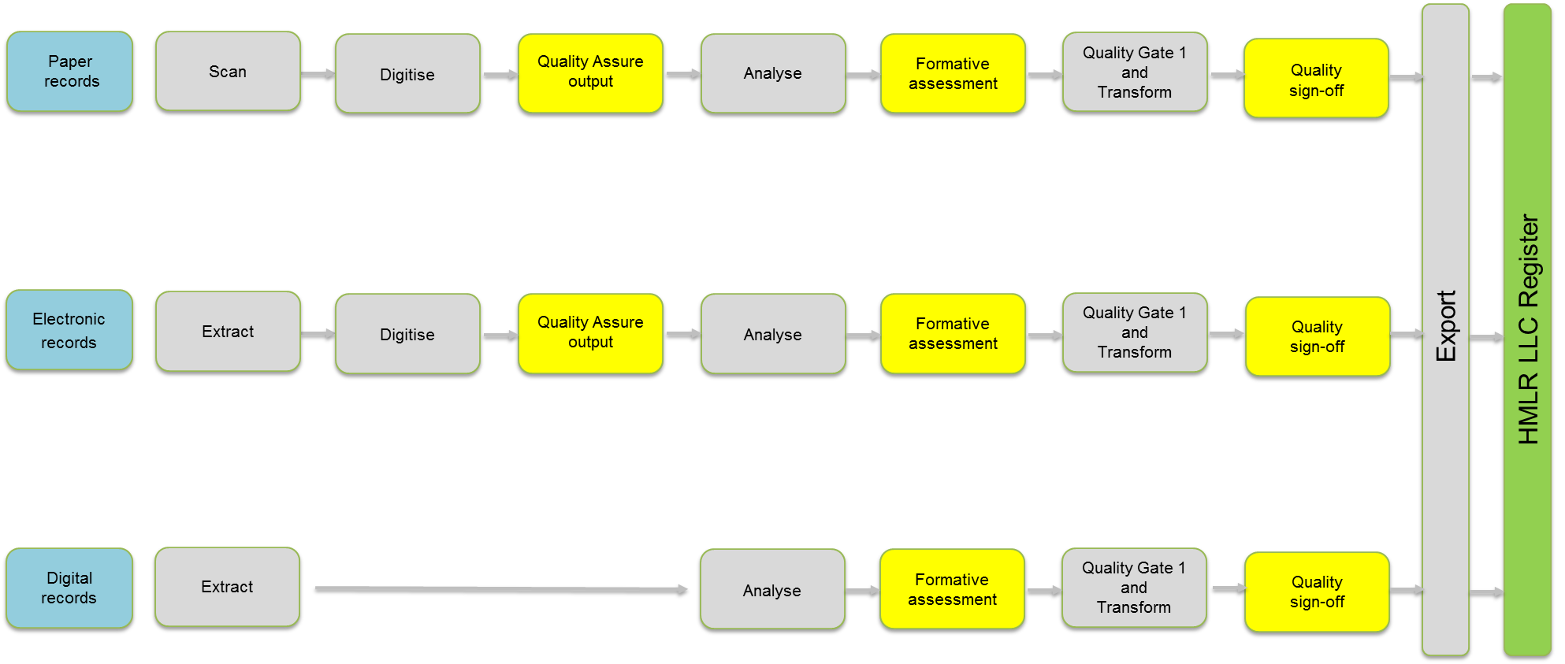
*Definitions

Scan Capture physical records in an electronic format
Extract Supply textual and spatial data from local authority system(s) for HMLR to digitise (where applicable) and transform
Digitise Convert non-digital textual and spatial records into a digital format
Analyse Evaluate data against LLC data standards
Transform Convert quality-checked records into a digital format to import into the LLC Register

Any questions?
llcproject@landregistry.gov.uk

